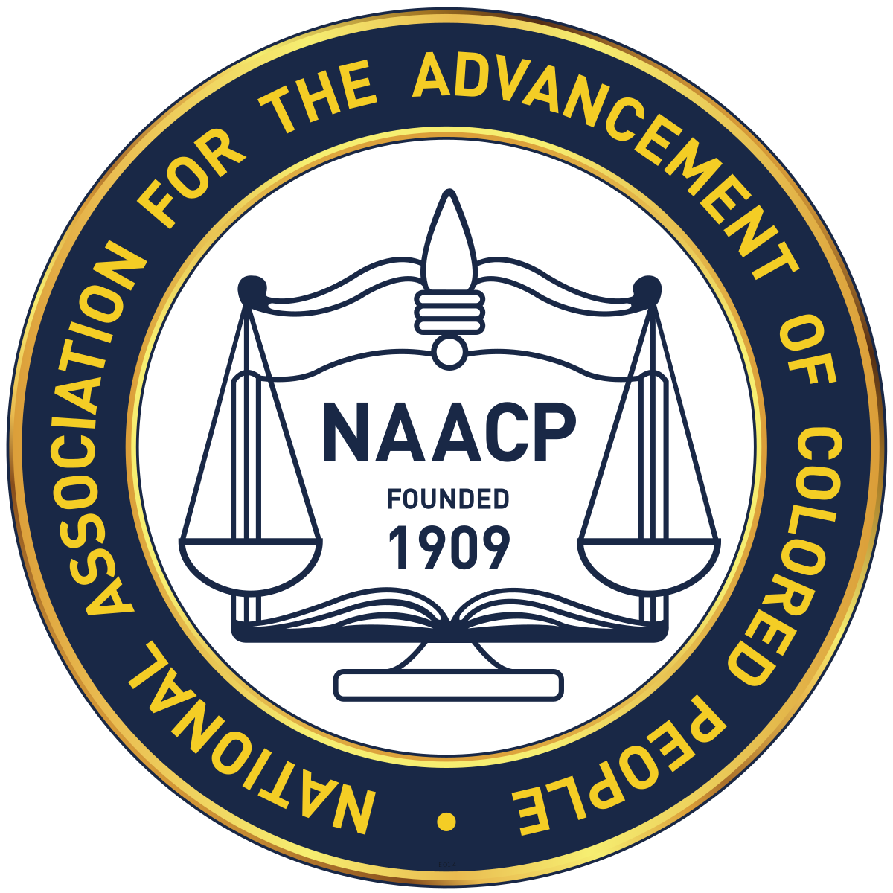

Press Release
For Immediate Release
January 28, 2024
Albemarle-Charlottesville NAACP
Contact – Corlis Anderson - ctanderson54@gmail.com

The Albemarle- Charlottesville NAACP Celebrates Founders’ Day

The Albemarle-Charlottesville NAACP will celebrate Founders Day’ on Sunday, February 11th at 4pm. The Celebration will take place at Chapman Grove Baptist Church, 2064 Stony Point Road, Charlottesville, VA 22911. The guest speaker will be Ms. Khaliah Ali, daughter of Mohammad Ali.
Khaliah Ali has served in numerous organizations, completed many literary efforts, made a variety of television appearances, and has participated in many speaking engagements in order to curate her father’s legacy, and her own humanitarian efforts. Her international experience in business, politics, and humanitarian aid provides a broad and flexible background, helping her to work in dynamic and diverse environments.

THE EVENT IS FREE AND OPEN TO THE PUBLIC

.

Albemarle-Charlottesville NAACP | P.O. Box 1522 Charlottesville, VA. 22902 | 434.220.1493
Web Site: ​www.albemarle-cvillenaacp.org | Email: ​ ​naacp1947@gmail.com

